Table of Contents
1.Intro….2
2.Task 1….2
3.Task2….3
4.Task 3….14
5.task 4….15
6.Referencees…..15

1. Introduction
This report is about a proof of concept (PoC) cloud design for WinLocal Giveaways using AWS. WinLocal is a small irish competitions and raffels company that got hit by a ransomware attack, attackers got into their web app and backend database and stayed hidden for like ten weeks. That’s bad because they collect personally identifiable information from competition entrants, so GDPR applies.
Their main issues: website goes down too often, no scalability when traffic spikes, and rubbish security monitoring. This report covers the AWS architecture I designed, the PoC implementation (VPC, bastion, Auto Scaling, load balancer, RDS, S3 backup), plus justification for AWS WAF and GuardDuty, and sustainability. No screenshots here.

2. Task 1:AWS Architecture Diagram
Architecture Diagram
Proposed AWS Architecture for WinLocal Giveaways
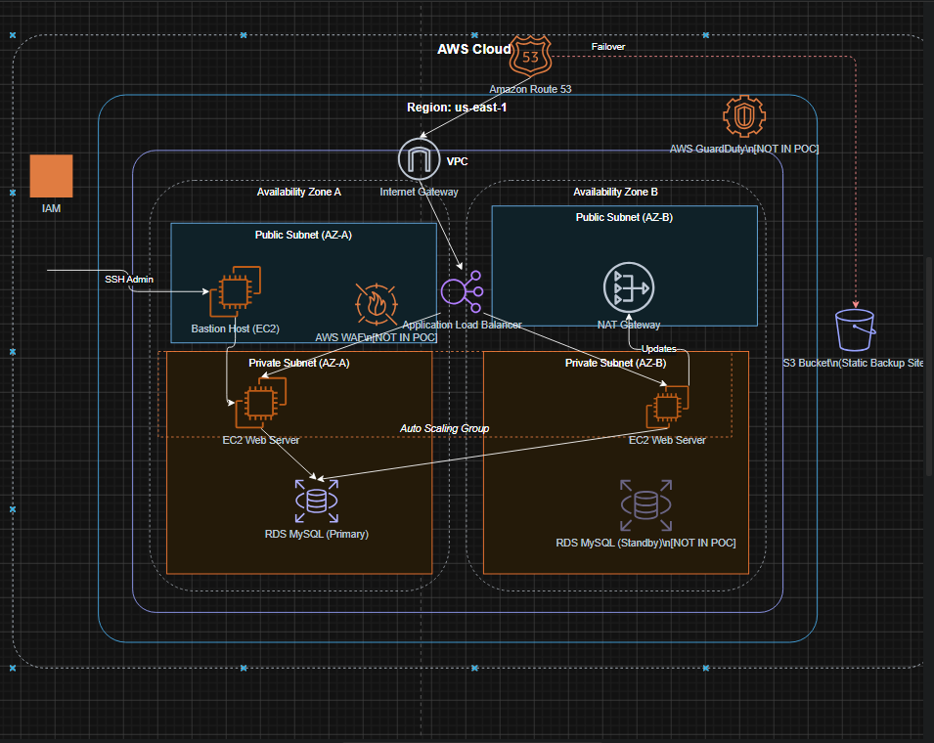
The diagram shows traffic from users hitting an Application Load Balancer (ALB) in public subnets across two Availability Zones (AZs). The ALB sends requests to EC2 instances in private subnets. Those instances talk to an RDS MySQL database also private. A bastion host in a public subnet lets admins SSH into private EC2s. The poc uses singleAZ RDS and 1-2 EC2s. AWS WAF and GuardDuty are conceptual only for production.

3. Task 2 Proof of Concept Implementation
Networking Design
I made a VPC with two AZs (eu-east-1a and eu-east-1b) for high availability. Each AZ has one public subnet (for ALB and bastion) and one private subnet (for web servers and RDS). Private subnets have no direct internet access they use a NAT Gateway. This keeps the database hidden.
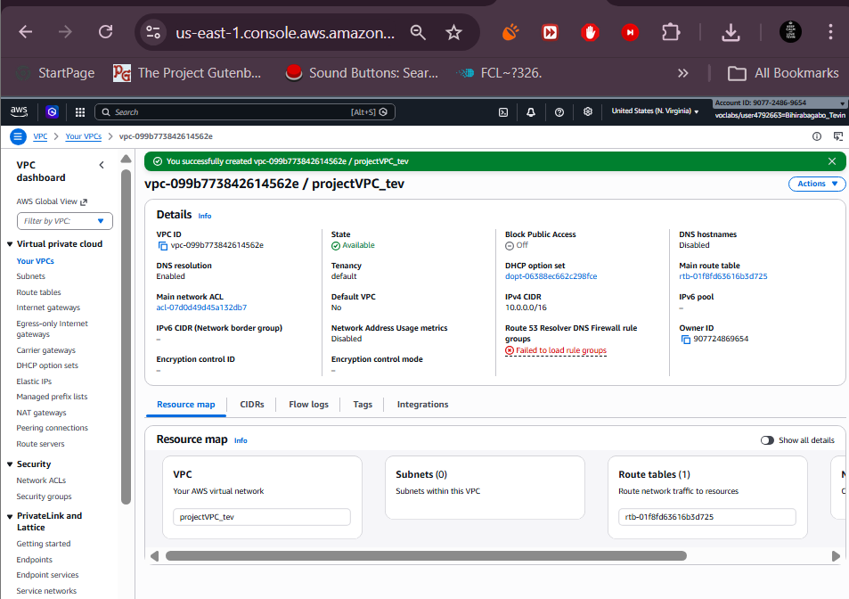
Bastion Host
A Bastion Host is a jump box in a public subnet. You SSH into it first, then from there into private EC2s. WinLocal needs this because their web servers and database should never be directly on the internet it reduces the attack surface a lot. Only the bastion has port 22 open, and only from my IP.
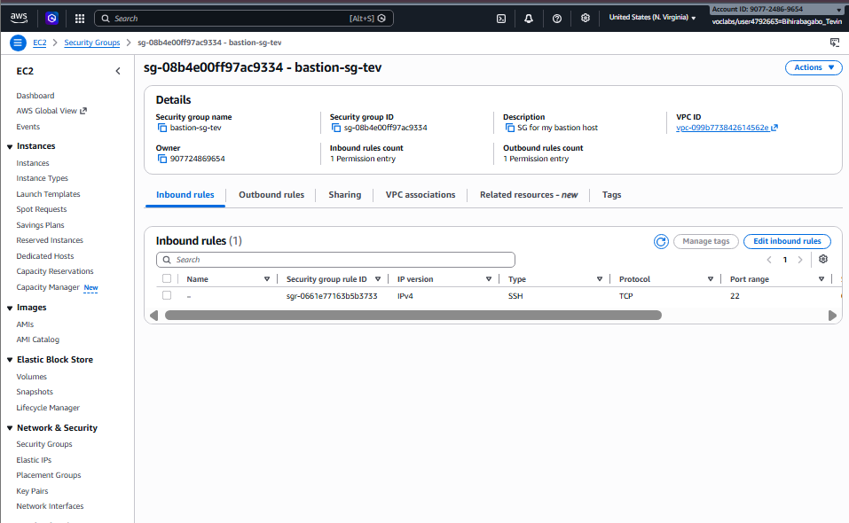
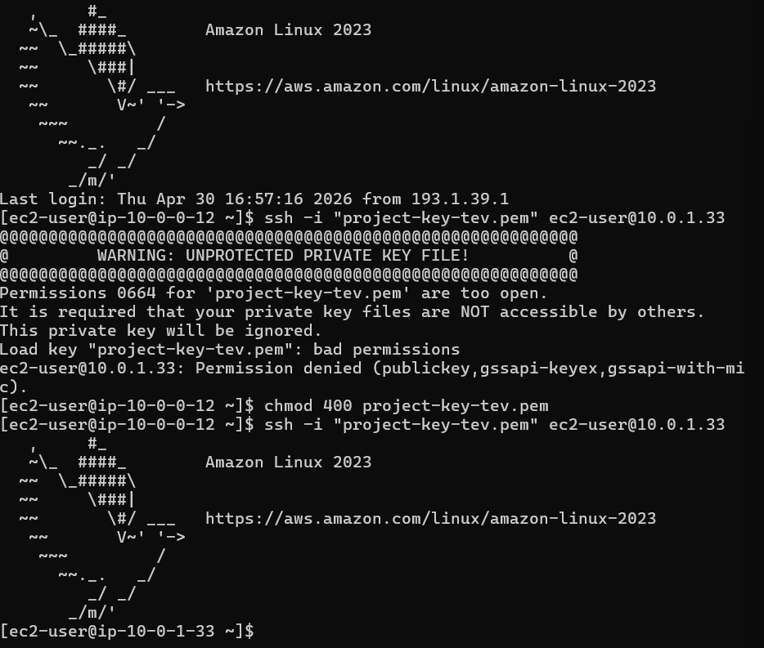
Amazon Machine Image (AMI)
An AMI is a blueprint for an EC2 instancee OS, software, config all in one template. I made an AMI from a configured web server so Auto Scaling can launch identical instances every time. No more manual config drift.
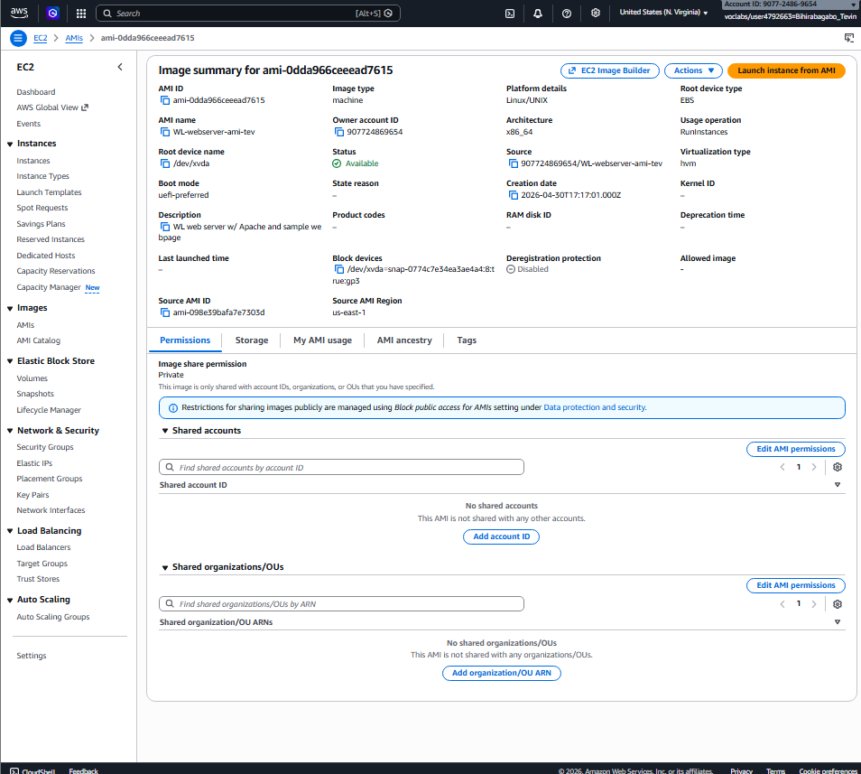

RDS Database
I deployed RDS MySQL inside a private subnet. PoC uses single AZ (db.t3.micro the free tier), not publicly accessible. The limitation is tht if that AZ dies, the database dies. Production needs MultiAZ for automatic failover.
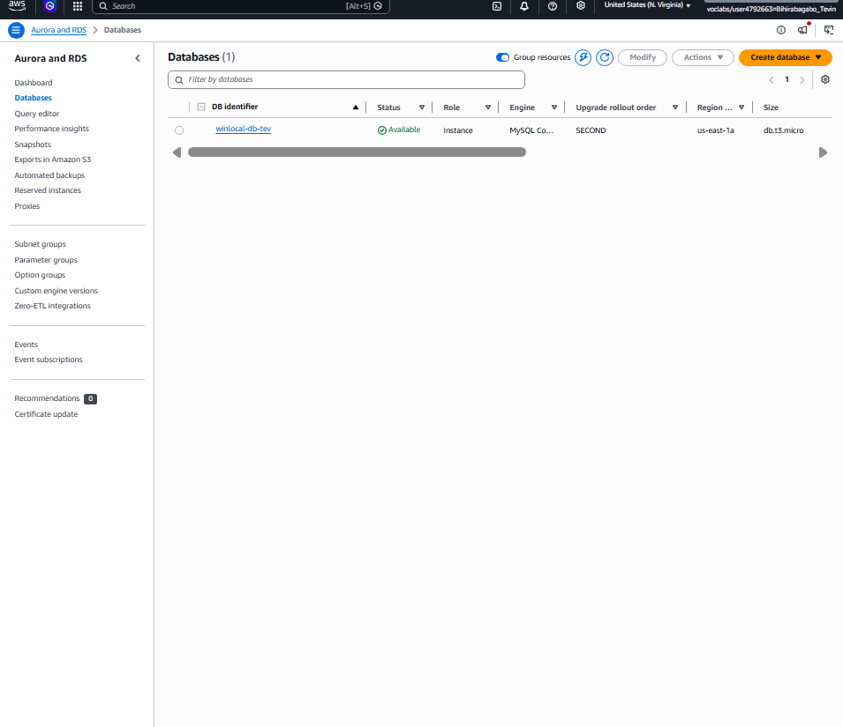
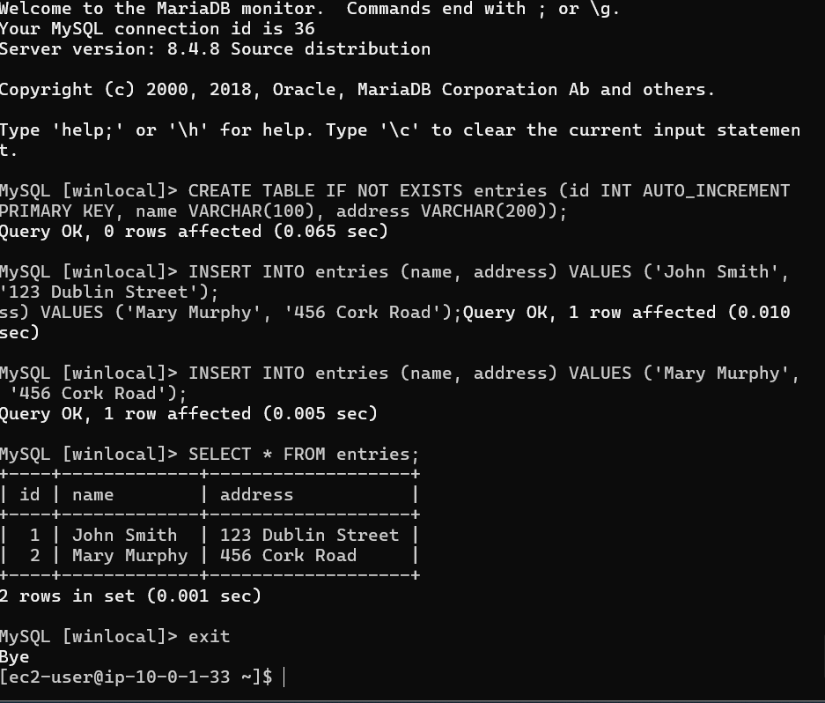
Auto Scaling Configuration
Auto Scaling Group with desired=1, min=1, max=2. A target tracking policy keeps CPU around 60%. Above 60%, AWS launches a second instance. Does that mean that the demand drops? It terminates the extra. Solves WinLocal’s scaling problem directly.
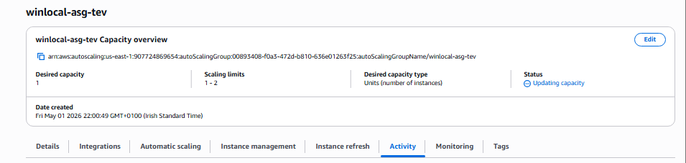
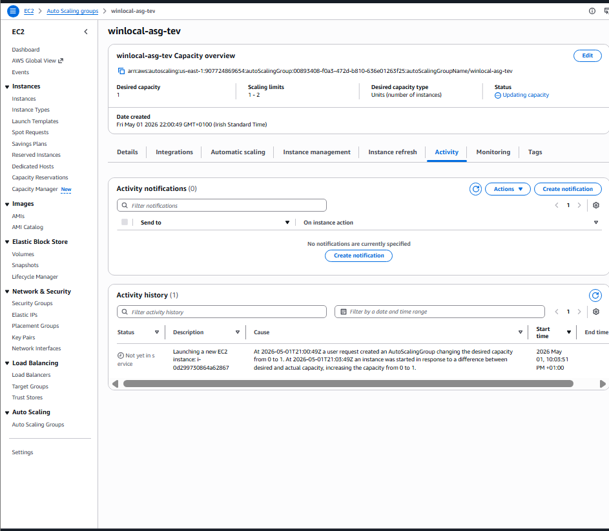
Load Balancer Configuration
The ALB spreads HTTP traffic across EC2 instances and does healthy checks, if one fails, traffic goes to the other. Gives WinLocal high avaiilabilit, replacing their old NetScaler.
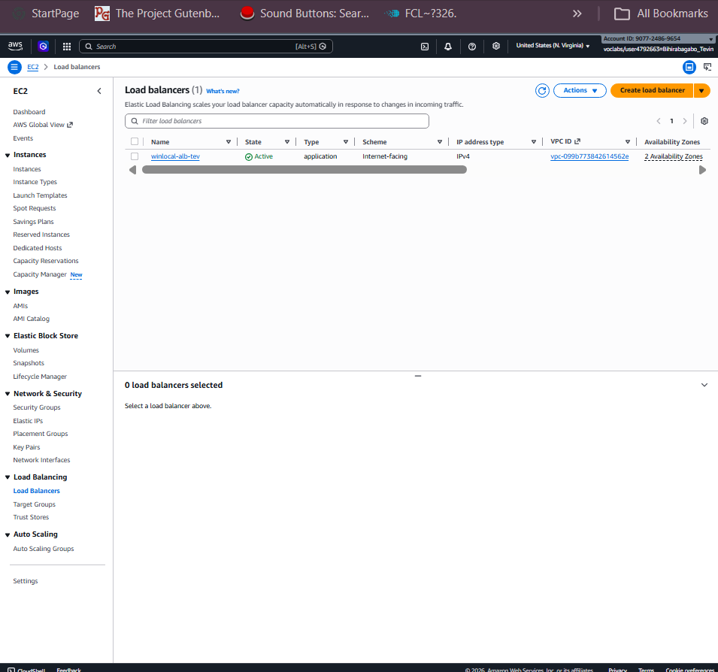
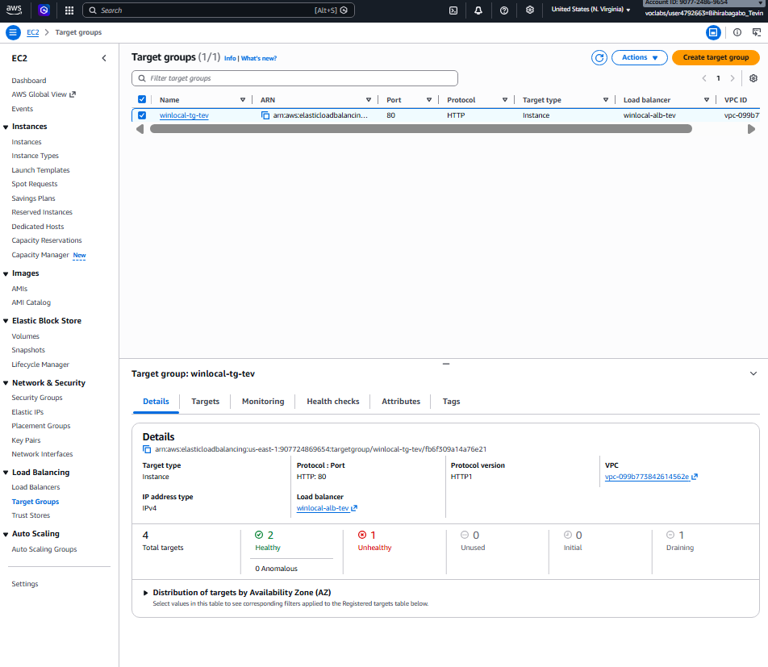
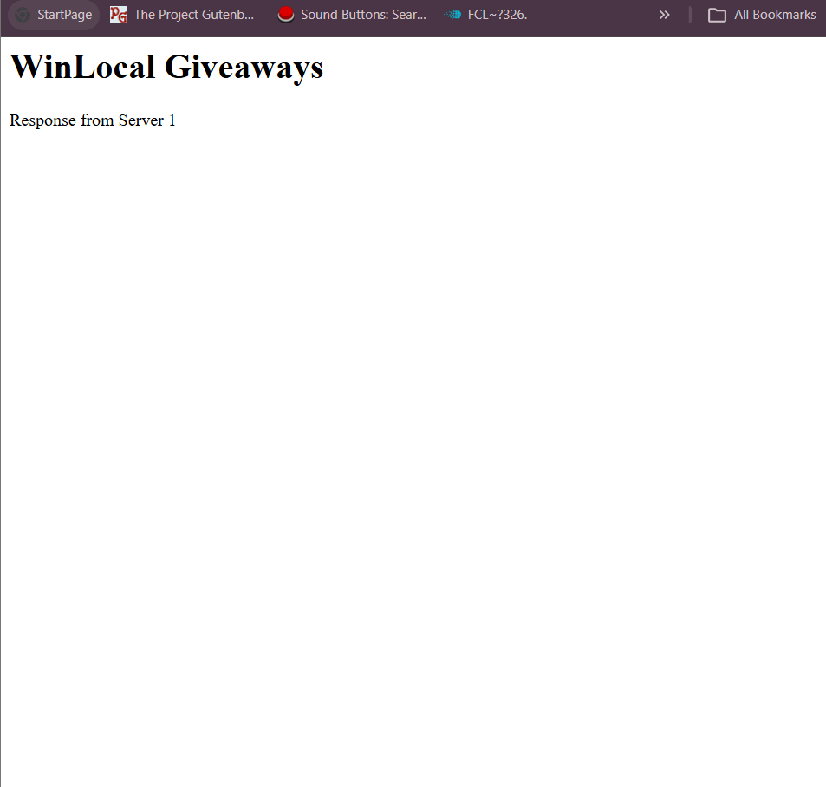
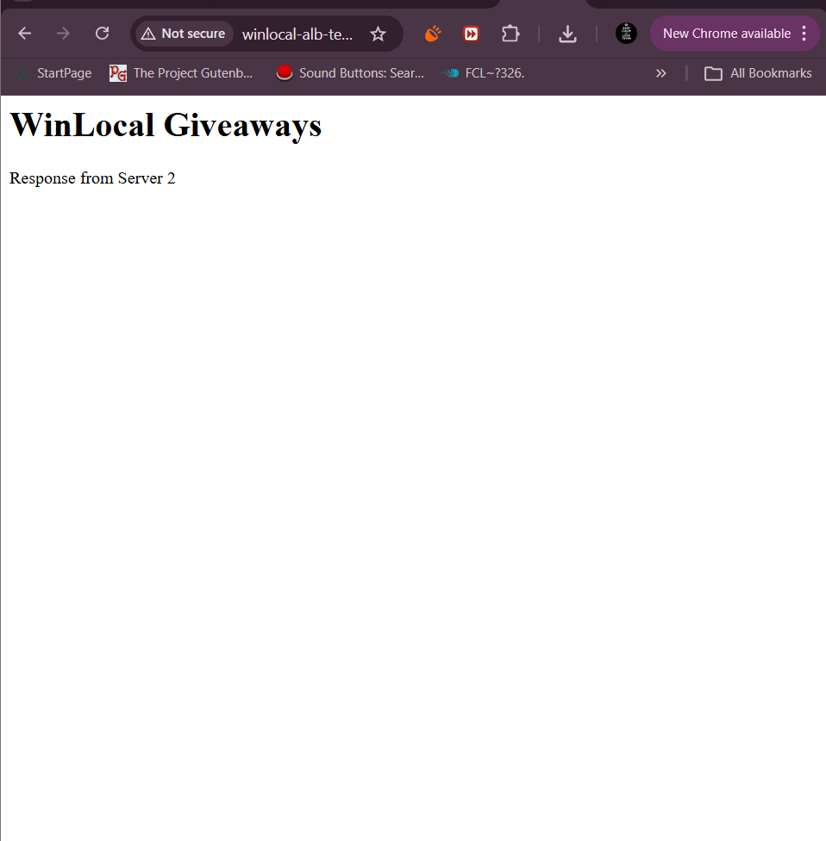
Security Implementation
Separate security groups for each layer security in depth.
- Bastion SG: SSH (port 22) only from my IP.
- Private EC2 SG: HTTP only from ALB SG, SSH only from Bastion SG.
- ALB SG: HTTP from anywhere (0.0.0.0/0).
- RDS SG: MySQL only from Private EC2 SG.
Database was thenn compltely hidden from teh internet
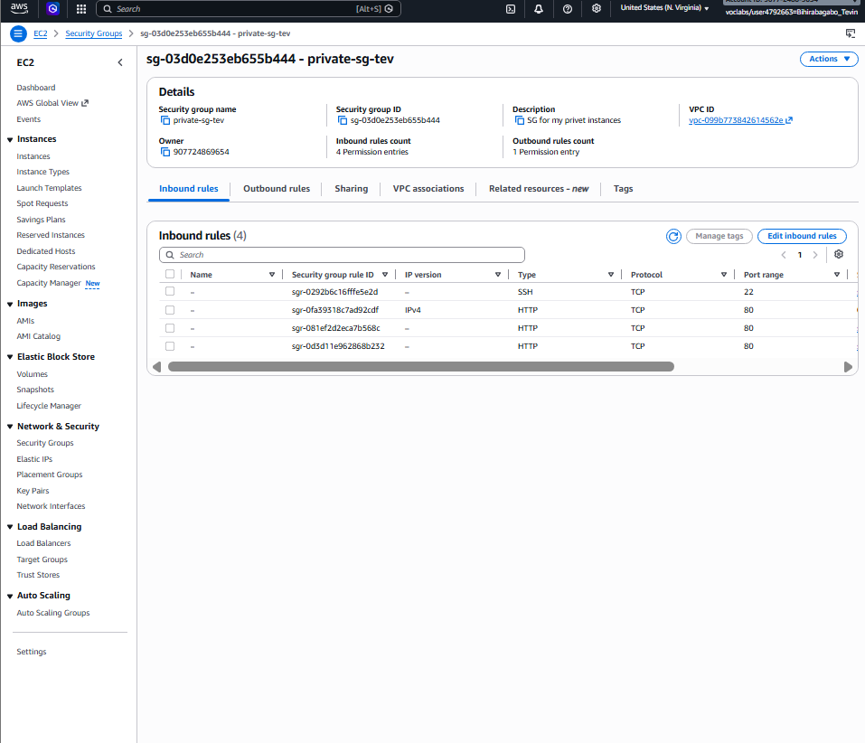
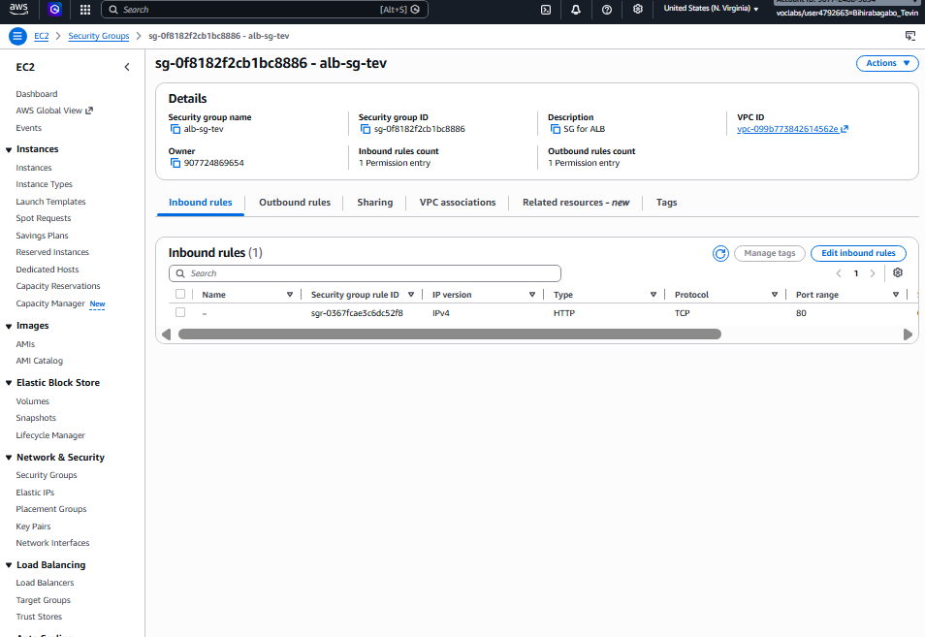
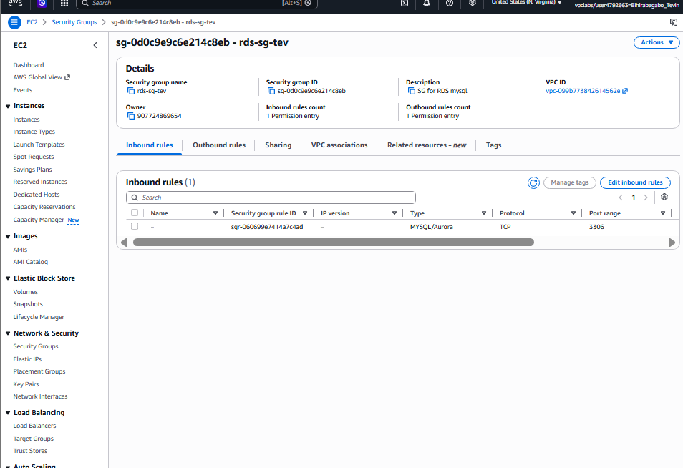
Static Backup Website
S3 bucket with static website hosting. Uploaded an index.html saying “We’re having issues check back soon.” In production, Route 53 would redirect users here if the ALB fails. S3 is highly available by default.

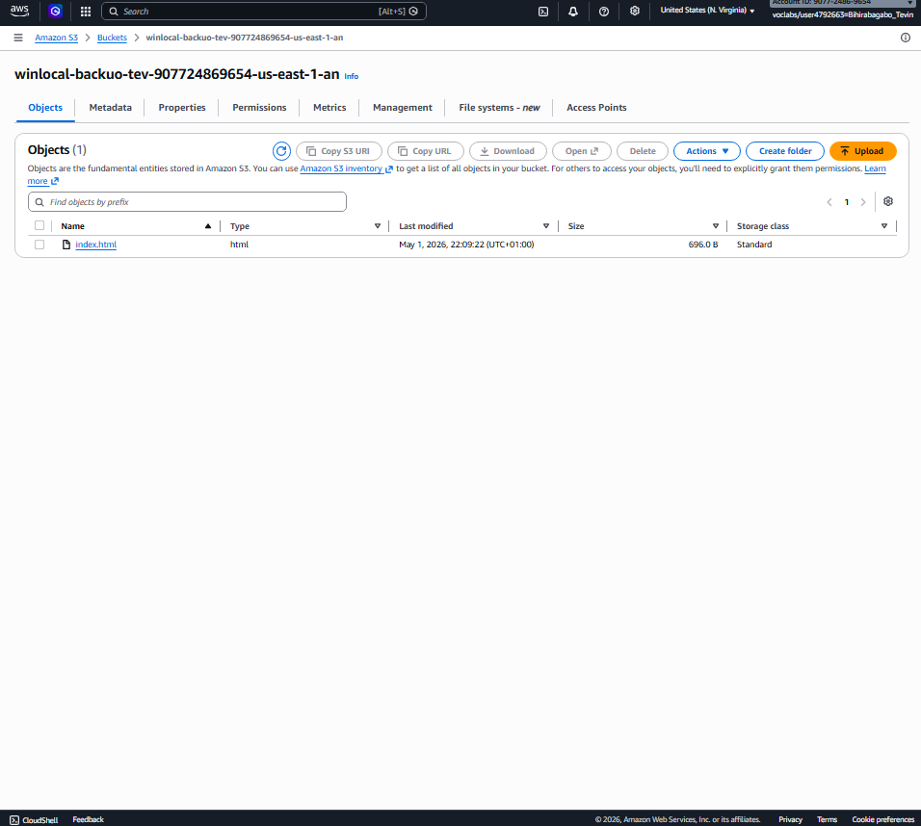
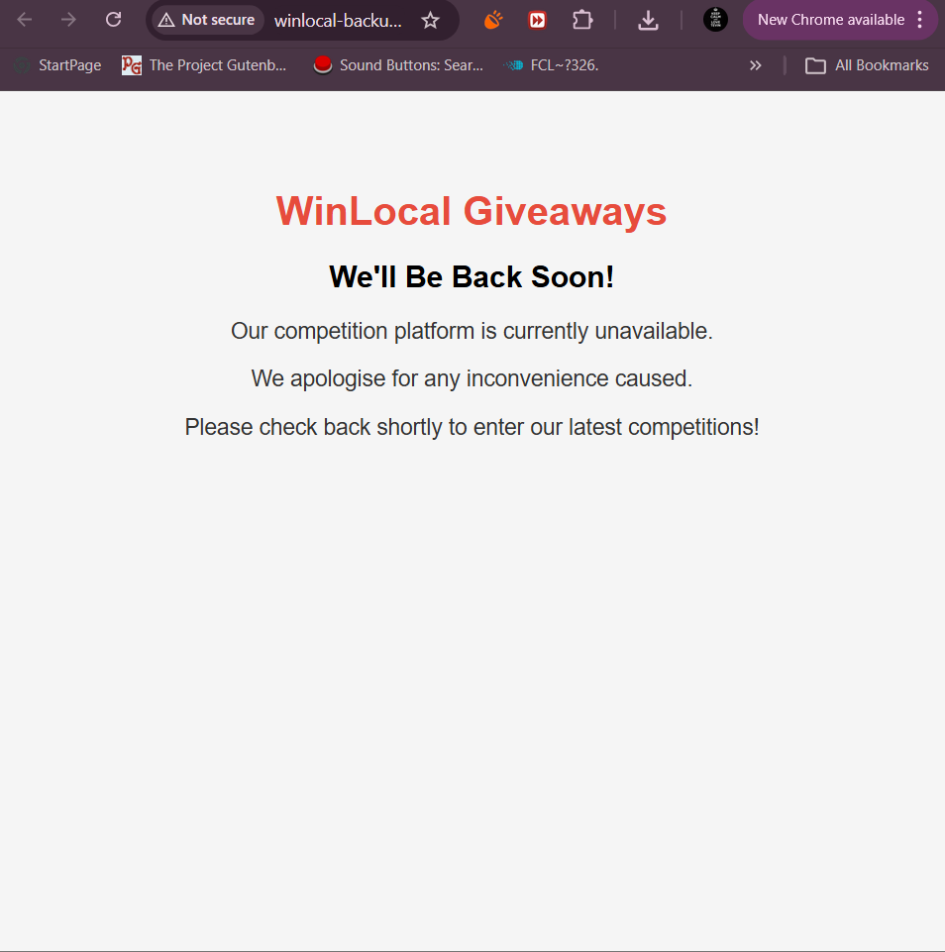

4. Task 3: Justification of Additional AWS Services
Service 1: AWS WAF
AWS WAF is a web application firewall that monitors and filters HTTP traffic (Amazon Web Services, 2024a). It sits in front of your ALB and blocks malicous requests before they reach your servers.
Why relevant to WinLocal? They suffered a ransomware attack partly because of no application layer security. AWS WAF blocks SQL injection and XSS (OWASP Top Ten) (OWASP, 2021), allows custom rules for suspicious IPs, and protects PII entry forms.
What problem does it solve? GDPR obligates WinLocal to protect customer data (Data Protection Commission, 2018). WAF adds an application level layer.
Why not in PoC? Extra cost and complexity but strongly recommended for production (Amazon Web Services, 2024a).
Service 2: Amazon GuardDuty
GuardDuty is continuous threat detection m onitors CloudTrail, VPC Flow Logs, DNS logs for malicious activity (Amazon Web Services, 2024b).
Why relevant? Attackers were undeteected for ten weeks at WinLocal no threat detection at all. NIST says implement continuous monitoring (NIST, 2018). GuardDuty would detect lateral movement, suspicious API calls, data exfiltration, and send alerts immediately.
What problem does it solve? Automates threat detection so WinLocal’s small IT team (one dev, two sysadmins) doesn’t have to manually watch logs.
Why not in PoC? Needs time to baseline normal behaviour, ongoing costs exclude from PoC but recommended for production.

5. Task 4: Sustainability
We first have to ask, what exactly is sustainability in the cloud? Minimising energy, carbon, and waste (Amazon Web Services, 2023). The PoC already has Auto Scaling, right sizing, managed services. But WinLocal can do more.
Five future improvements:
- Use AWS Graviton Instances: ARM based chips that use up to 60% less energy for same performance (Amazon Web Services, 2024).
- S3 Intelligent Tiering : automatically movves infrequently accessed data to cheaper, lower energy storage (Amazon Web Services, 2023).
- Cost Explorer & Compute Optimiser: recommends more efficient instance types (Amazon Web Services, 2023). Stop over-provisioning.
- Choose regions with renewable energy: Ireland (eu-east-1) is good, but expand wisely (Amazon Web Services, 2023).
- Schedule non-production resources: stop dev/test instances outside business hours using Instance Scheduler. Huge energy saving.
Conclusion
The PoC is already decent for sustainability, but these extra steps will reduce WinLocal’s carbon footprint as they grow (Amazon Web Services, 2023).

6. Conclusion
This project delivered a working AWS PoC for WinLocal Giveaways that directly adddresses their three big issues: availability, scalability, and security. The load balancer, Auto Scaling (60% CPU policy), bastion host, private RDS, and s3 backup website all work together. Security groups enforce securtity in depth the database has zero internet access.
The PoC proves the cloud solution can handle traffic spikes and survive instance failures. However, it uses single AZ RDS and lacks threat detection or a web application firewall.
Next steps for production:
- MultiAZ RDS for automatic failover
- AWS WAF in front of the ALB to block SQLi/XSS
- GuardDuty for continuous threat detection (critical after their 10 week breach)
- Route 53 failover to the S3 backup website
- Graviton instances for better sustainability
WinLocal’s tiny IT team will benefit massively from managed services that run themselves Auto Scaling, RDS, and GuardDuty don’t need babysitting.

7. References
Amazon Web Services (2023) AWS Well-Architected Framework — Sustainability Pillar. Available at: https://docs.aws.amazon.com/wellarchitected/latest/sustainability-pillar/sustainability-pillar.html
Amazon Web Services (2023) Amazon S3 Intelligent Tiering. Available at: https://aws.amazon.com/s3/storage-classes/intelligent-tiering/
Amazon Web Services (2023) AWS Compute Optimizer. Available at: https://aws.amazon.com/compute-optimizer/
Amazon Web Services (2024a) AWS WAF Developer Guide. Available at: https://docs.aws.amazon.com/waf/latest/developerguide/what-is-aws-waf.html
Amazon Web Services (2024b) Amazon GuardDuty User Guide. Available at: https://docs.aws.amazon.com/guardduty/latest/ug/what-is-guardduty.html
Amazon Web Services (2024) AWS Graviton Processor. Available at: https://aws.amazon.com/ec2/graviton/
Data Protection Commission (2018) Guide to the General Data Protection Regulation. Available at: https://www.dataprotection.ie/en/individuals/know-your-rights/guide-general-data-protection-regulation-gdpr
NIST (2018) Framework for Improving Critical Infrastructure Cybersecurity. Available at: https://nvlpubs.nist.gov/nistpubs/CSWP/NIST.CSWP.04162018.pdf
OWASP (2021) OWASP Top Ten. Available at: https://owasp.org/www-project-top-ten/

